Project name :

Convert from Json to csv.

Project description :

this project used to convert from Json format to csv format.

Project timeline, milestones :

Design for Gui 1 week

Implementation code 1 week

Total time : 2 week

Test 2 day.

Project flowchart or pseudo code :

Write csv file

Convert to csv

Read Json file

Programming language used :

python

Input format and layout :

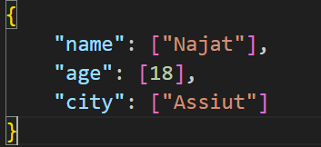

output format and layout :

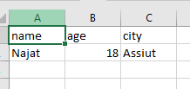

One test scenario with input and expected output :

Input : 

Output : 

Make simple calculator :

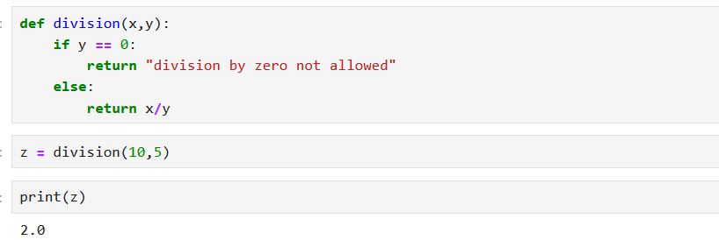

Print numbers from 1 to 100000 :

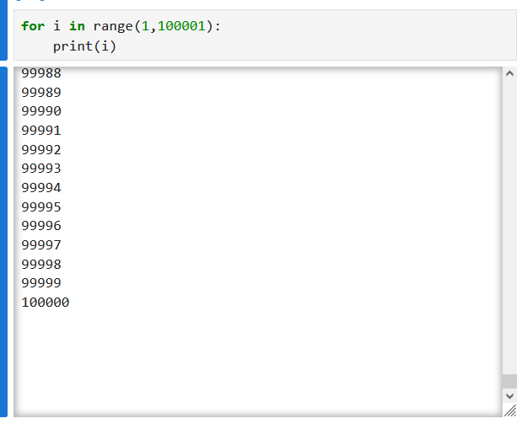

Convert from string to float and integer :

